Lord Change Me (Current)
December 18th, 2024

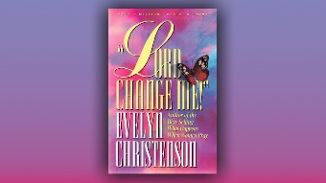
Precious family, Mother Clare began, we are entering a new era, it requires us to leave the old patterns of our thinking behind and walk into the light, not sharing the works of darkness but staying in the light.

Do you truly want to be in God’s perfect will for your life? Then we must think like God by uniting what goes on in our minds to His Mind and blocking out all the darkness we are habituated to listening to and seeing.

I have realized that the news most people watch for an hour, or more is littered with bad news, wars, accidents, economic scares.

In Romans 12:2, Paul tells us exactly how to do this, “Do not conform to the pattern of this world, but be transformed by the renewing of your mind. Then you will be able to test and approve what God’s will is—His good, pleasing and perfect will.” Amen.

Our whole world is made up of different vibrations and wavelengths of light. There are very low vibrations of light and very high. Worshiping God and praying in tongues is the highest vibration. War crimes, violent and bloody deaths are the lowest, alongside anything that inspires fear.

I know I am not functioning at my best, the Holy Spirit put it on my heart to pray, “Lord Change Me,” and I spent the whole day praying and asking, “Lord I know I am not where I should be, please change me.

By the way, I highly recommend Evelyn Christenson’s book, “Lord Change Me”, this book will train you to hear His voice when you read the Scriptures, and from that starting point you will begin to hear and recognize His voice in everything from books to bumper stickers. The Scriptures teach us about truth, but the Still Small Voice is hidden in-between the lines and becomes a Rhema that speaks directly to your heart.

God bless you dear Heartdwellers, and we pray for the renewing of our mind so that in all things, His will be done!

